Software Requirements Specification

for

Smart Parlour Management System

Version 1.1

Prepared By

Syeda Fariha Sultana (19-39718-1)

MD. Amimul Ahasun Anas (19-40149-1)

Atia Sultana Mim (19-40121-1)

Easinul Abedin Sayem (19-40291-1)

Fathema Akter Moonmoon (19-40161-1)

American International University-Bangladesh (AIUB)

Date: 12 Dec 2022

Table of Contents

Table of Contents ii

Revision History ii

1. Introduction 1

1.1 Purpose 1

1.2 Document Conventions 1

1.3 Product Scope 1

1.4 Intended Audience and Reading Suggestions 2

1.5 References 2

2. Overall Description 2

2.1 Product Perspective 2

2.2 Product Functions 2

2.3 User Classes and Characteristics 3

2.4 Operating Environment 3

2.5 User Documentation 3

2.6 Assumptions and Dependencies 4

3. External Interface Requirements 4

3.1 User Interfaces 4

3.2 Hardware Interfaces 6

4. System Features 6

4.1 System Feature 1 6

5. Other Nonfunctional Requirements 8

5.1 Performance Requirements 8

5.2 Safety Requirements 8

5.3 Security Requirements 8

5.4 Software Quality Attributes 8

5.5 Business Rules 9

Revision History

|  |  |  |  |
| --- | --- | --- | --- |
| **Name** | **Date** | **Reason For Changes** | **Version** |
|  |  |  |  |
|  |  |  |  |

# Introduction

## Purpose

The name of this project is “Smart parlour management system”. It is a digital web-based system. This system is to give home services at the right time without any problem. In our country many areas people could not be able to go to parlor at any moment for many reasons. In this app, user can get services if they register an account. Through this system, user can find nearest parlor, can get every parlour detail, location, price in one system and they can book an appointment.

## Document Conventions

The normal text font size that has been used in this document is 12pt with 1.5 line spacing, and for all the texts “Times New Roman” font is used, and justified aligned.

Defined terms are highlighted with bolding. Requirements will come with priority to indicate in which order they will be implemented. Versions might be released with only some of the total list of requirements implemented.

## Product Scope

An online parlour called Smart Parlour Management System targets to ease parlour management issues and to create a convenient and easy-to-use application for customer, trying to book schedule. The system is based on a relational database with its parlour management and reservation functions. This system will be controlled by a database server supporting in the major cities around the Bangladesh as well as thousands of parlours by various parlours details. Above all, system provide a comfortable user experience along with the best pricing available. On this system it will give all parlour details, location, price details in one system. If anyone cannot go parlor, he or she easily get service at home with system.

## Intended Audience and Reading Suggestions

This document is intended to be read by the stakeholders including Project Managers, Developers, Marketing Staff, Users, Testers. Some chapters may have references to external links, and the readers are encouraged to follow and have a glance through the links/resources for better contextual understanding of this document.

## References

* <https://dl.ucsc.cmb.ac.lk/jspui/bitstream/123456789/4047/1/1420992.pdf>
* <https://iarjset.com/upload/2017/si/NCETETE-2017/IARJSET-NCETETE%205.pdf>
* <https://www.semanticscholar.org/paper/Prototype-Development-For-Online-Reservation-System-Maryani-Nindito/21a19f9fcebb6b505f9e386d6170b39d838d0033>
* <https://themeforest.net/item/spa-treats-health-spa-saloon-psd/screenshots/2619042?index=>0

# Overall Description

## Product Perspective

Using this platform user can view all the parlours which are partner with our parlour management system and also view their services. Like food panda serves a similar need in the restaurant industry, but our system brings clients and parlours together online. When customers search the parlour then the system will show all the available parlours on their locations and if by chance the time you have searched is not available then it will also show the next vacant slots on our system which is registered with our platform on that location. It will be useful for customers because now they have their bookings with the slots available. It will also remove all the paperwork as the owner will have access to all the customers details and their records to serve them better.

## Product Functions

1. Functional: Registrations, Login (Manager, Customer, Employee, Beautician, Cashier)
2. Non-Functional: Security, Response time, Memory

## User Classes and Characteristics

There will be many kinds of users who will have access to the software.

1. **Manager**: They will have the authority to manage or organize anything for every user. The manager will maintain the overall tasks and estimates schedule, effort, and resources.
2. **Employees**: They will do their own respective work.
3. **Customer**: They will share about the problems they are facing & take their services.
4. **Cashier**: They will see the overall software payment sections on both online or offline. They will update the payment status on time so that users can get a pleasant experience.
5. **Beautician**: They will accept or decline the service that they can provide to the customers.

## Operating Environment

**Operating System:** For native application android, and on server Linux.

**Hardware Platforms:** PC or android device

**OS Version:** For native application android 9 or above.

**Software Components:** any browser (Chrome, Mozilla Firefox, Opera)

## User Documentation

Users are given access to user documentation that provides an overview of the system as part of the system itself. The entire product description and all the carefully laid out methods for installing the software will be included. Users will have the chance to use the system without any issues. The email addresses to contact us should you need to are listed in the user handbook. Cross-referenced indexes are frequently used to list tasks in an alphabetical or logically arranged manner, making it easier for users to find the specific information they need.

## Assumptions and Dependencies

Each center user has account created and authenticated by admins. This Website can be accessible within parlour company’s internet and other user can see the all details about the parlour services and details. Each user must first login itself to present him/her after entry in service. This will be done automatically. No user can share their username and password to each other. There is no limitation in the operating system in which our system will work. The System and the database will work on a server that needs to be always online. Users can access the system with any internet browser.

# External Interface Requirements

## User Interfaces

Given templates are used to give an over view of the website.

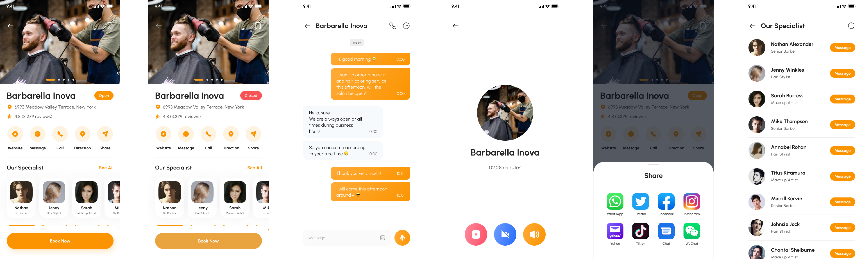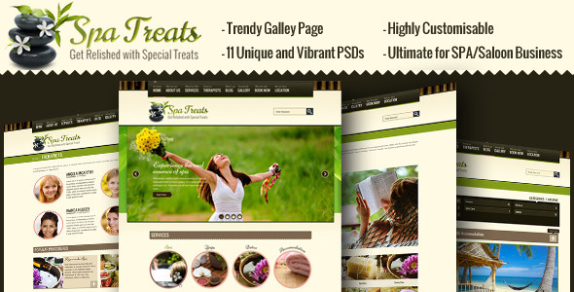

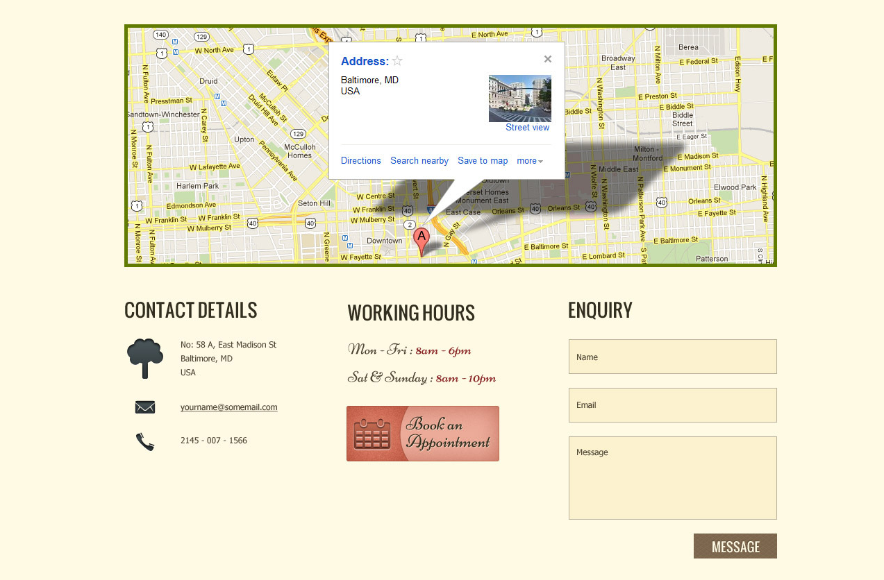

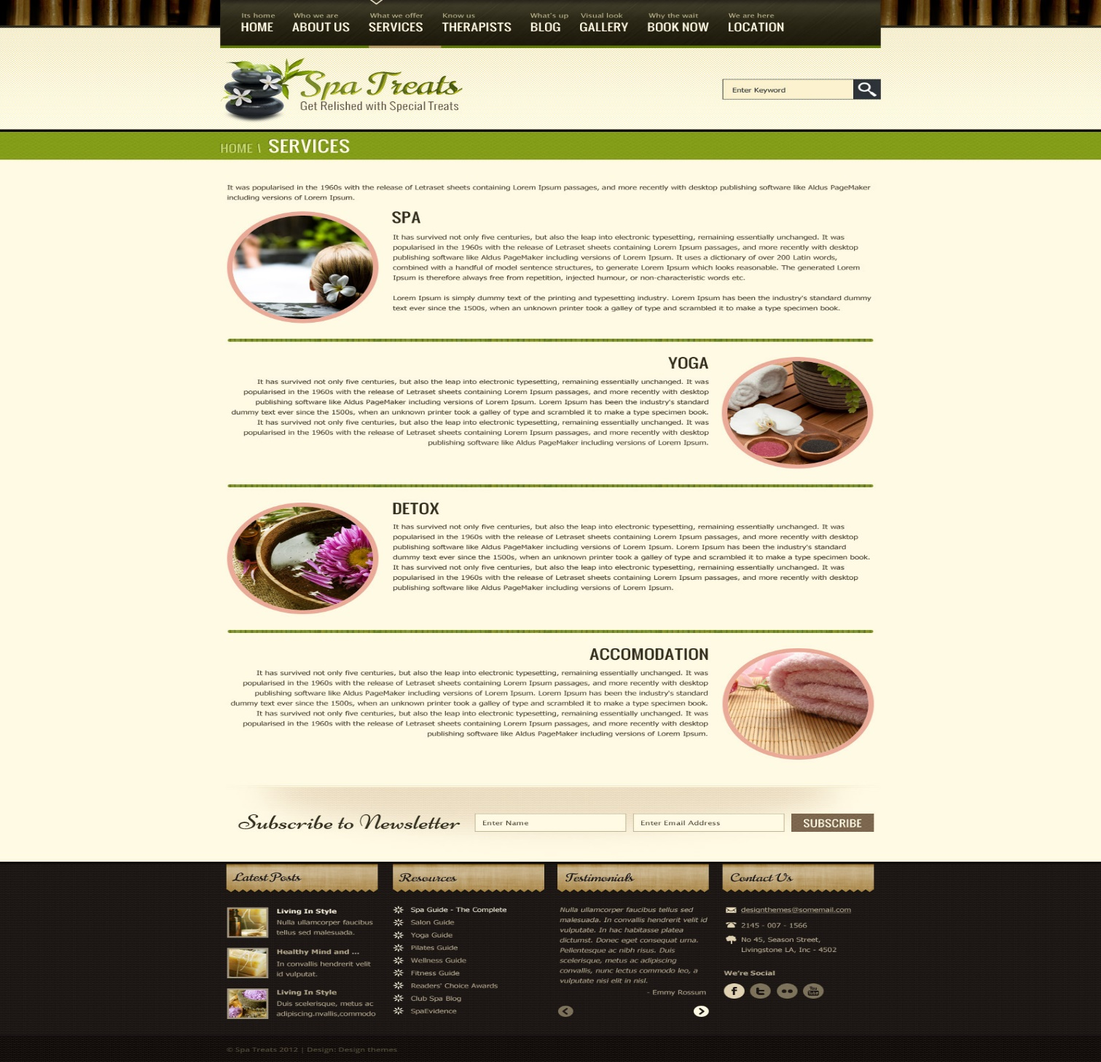

## Hardware Interfaces

Android or IOS devices or any device with recent release of major web browsers (e.g., Firefox, Chrome, Edge, Safari) can use the software. The client side of the software must be connected to the server side with either Https or secure WebSocket protocol. Both Touch and pointing devices are supported.

# System Features

The system features are described below:

## System Feature 1

1. **Software Login**

The user has to login to run the software and the user has to resister to create an account using user’s general information.

1. **Background Color**

**2.1**System by default shows black background color to the user. But it also allows user to choose their preferred color.

**2.2** After choosing the color, the user can also change it and does notneed to set it up every time because it will automatically be saved.

**Priority level:**Low.

**Precondition:**Users need to login into the account first.

**Cross-references:**  N/A

1. **Language**

**3.1** System will automatically set the language to English. But also allow the user to choose their preferred language.

**3.2** After choosing the language, the user can change it. anytime and does notneed to set

it up every time because it will automatically be saved.

**Priority level:**Low.

**Precondition:**Users need to login into the account first.

**Cross-references:** N/A

**4. Parlour location and its quality**

**4.1** General time will be selected according to the quality of the reviews

given by the users including the location near the parlour.

**4.2** Higher rate will be priority, but higher rates inability will cause the system to lower the

rates choose from there.

**Priority level:** Medium

**Precondition:** Users need to login into the account first.

**Cross-references:** N/A

**5. Online/Offline appointment with Beauticians profile**

**5.1** Users will have the choice to select from a wide range of beautician service

**5.2** Users will also have access to all the general information of the parlour or beautician they select

**5.3** users will also have the option of offline and online care service

**Priority level:** High

**Precondition:** Users need to login into the account first.

**Cross-references:** N/A

**6. Payment**

**6.1** Users have both online and offline payment option

**6.2** Users for online can booked service from our site directly

**6.3** Users for offline must able pay in person

**Priority level:** High.

**Precondition:** User must have a valid account and password

**Cross-references:** 10

**7. Contact Us**

**7.1** User will have the ability to contact the manager at anytime

**Priority level:** Low.

**Precondition:** Users need to login into the account first.

**Cross-references:** N/A

**08. FAQ**

**08.1** There will be a question-and-answer section for the users any query about service and details.

**Priority level:** Medium.

**Precondition:** Users need to login into the account first.

**Cross-references:** N/A.

**09. Update**

**09.1** The app or website will get a regular system update and an occasional maintenance

**Priority level:** Medium.

**Precondition:** User must have a valid account and password

**Cross-references:** N/A.

**10. Settings & Privacy**

**10.1** Users can update their name, phone number, email addresses. at any given time

**10.2** Users have the option to delete or deactivate their account at any time

**10.3** Users personal information and location will be hidden from other users.

**Priority level:** Medium.

**Precondition:** User must have a valid ID and password

**Cross-references:** N/A

**11. Account Security**

**11.1** Users can change their password any time they want

**11.2** Users will have the option to enable two-factor authentication. and get alerts about unrecognized login.

**Priority level:** Medium.

# Other Nonfunctional Requirements

## Performance Requirements

This system has no performance requirements because the end user's internet connection determines the server request and response.

## Safety Requirements

Account Security is a very important feature in our system. Users can change their password any time they want. Users will have the option to enable two-factor authentication. and get alerts about unrecognized login.

## Security Requirements

Users can update their name, phone number, email addresses. at any given time. Users have the option to delete or deactivate their account at any time. Users’ personal information and location will be hidden from other users.

## Software Quality Attributes

1. There may be multiple managers creating the project, all of them will have the right to create changes to the system. However, the members or other users cannot make changes.
2. The project should be open source.
3. The software interface should be flexible and user friendly

## Business Rules

The system shall provide a help and support menu in all interfaces for the user to interact with the system. The user can use the system by reading help and support. The system should always be available for access at all times. The users should avoid illegal rules and protocols. Neither any admin nor members should cross the rules and regulations.